CE100 Lab Report 8

Breadboard Construction

Justin Fortner

Lab 1C

TU/TH 1:30-3:20

12/09/17

**Description:**

In this lab we are to design two circuits using provided chips, wires, and a breadboard. The first circuit being a 9 inverter ring oscillator. From this ring oscillator we are to calculate the propagation delay for the inverters within the chip. The other circuit being an edge triggered flip flop using 6 NAND gates.

**Methods:**

**Part 1-Ring Oscillator and Propagation Delay:**

For the ring oscillator 9 inverters were to be connected in series with one another. This took two of the provided inverting chips in order to accomplish this. Each chip held 6 inverters. Thus 3 inverters were not used. This can be shown in the following wiring diagram:

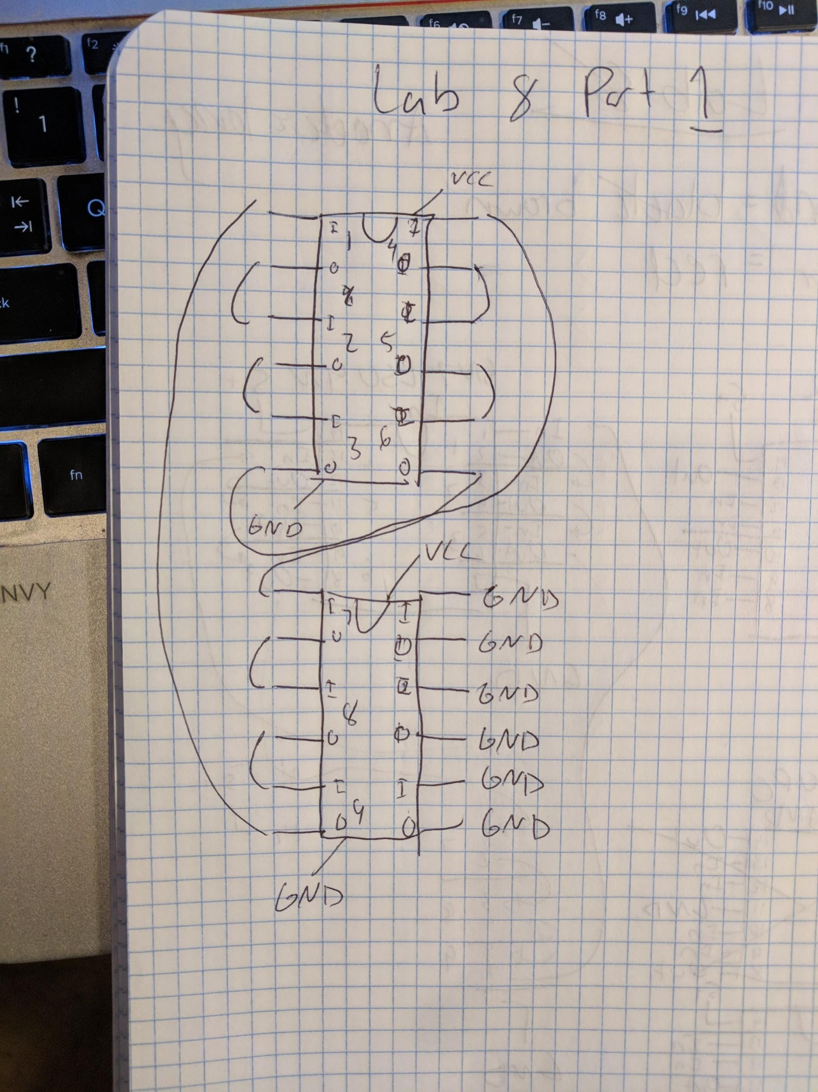

The inputs to these unused inverters were attached to ground to avoid interference. Once the circuit is completed the oscilloscope must be calibrated and properly attached to the circuit. Achieve a stable waveform and record the observations. From these observations calculate the propagation delay.

**Part 2-Edge Triggered Flip Flop:**

For this part of the lab I chose to implement a negative edge triggered flip flop. This flop flop consisted of 6 NAND gates. The inputs and outputs are wired up as displayed in the following wiring diagram:

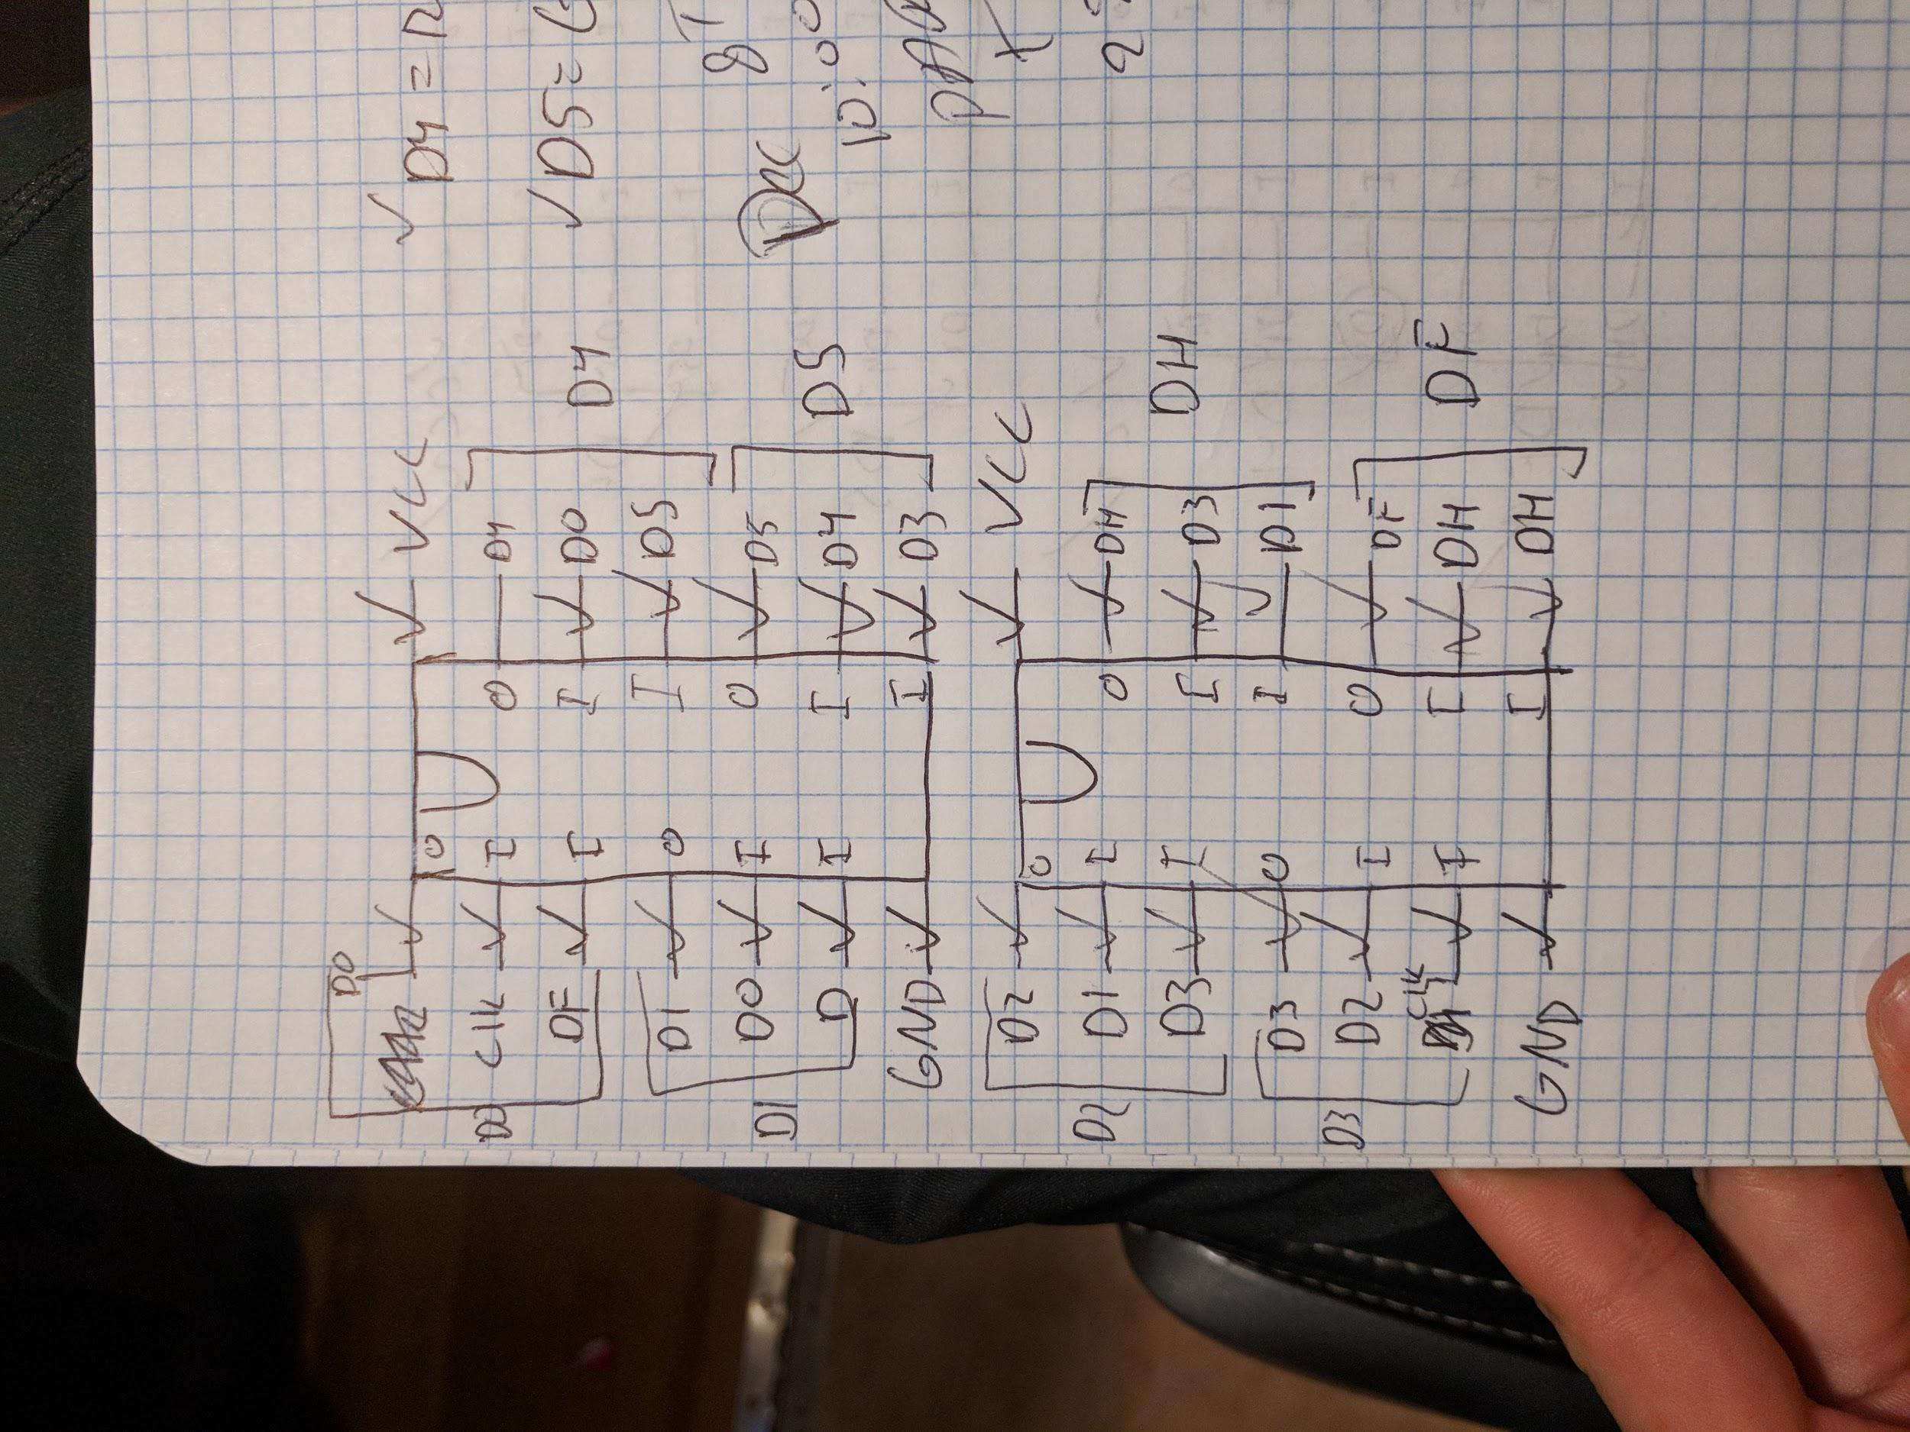

**Results:**

**Part 1-Ring Oscillator and Propagation Delay:**

Transitions/Division = ~4 Transitions/Division

Time/Division = 20 Nanoseconds/Division

Number Of Inverters = 9

Propagation Delay = (4 Transitions/Division * 20 Nanoseconds/Division)/ 9 Inverters = 8.88 Nanoseconds

Expected propagation delay = 8 nanoseconds

The completed circuit can be seen on the next page:

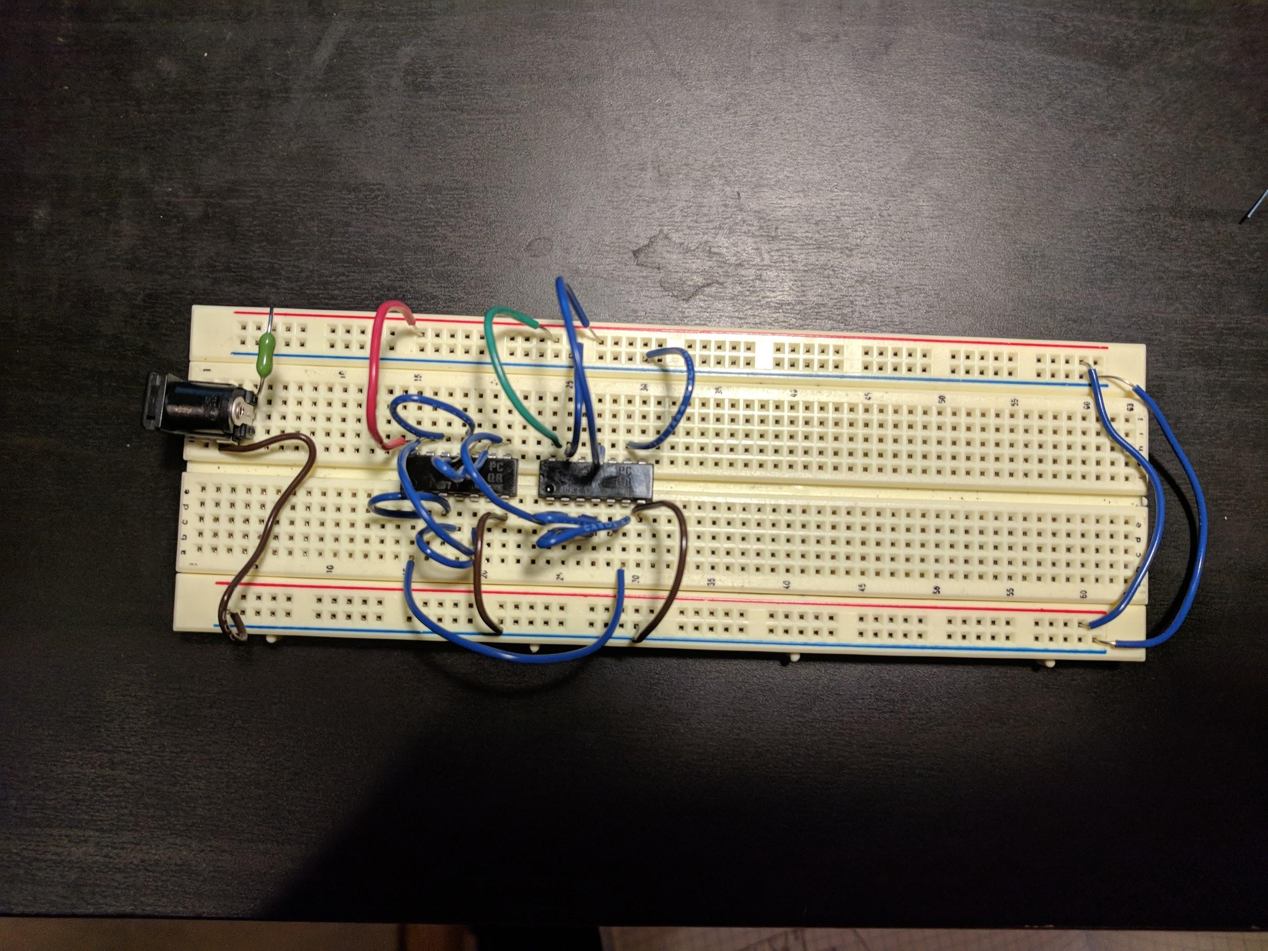

**Part 2-Edge Triggered Flip Flop:**

When my input D was high the yellow LED would be on and my output Q would go high and the greed LED would be on. The red LED would be off. When my input D was low the yellow LED would be off and my output ~Q would go high and the red LED would be on. The green LED would now be off. The completed circuit can be seen on the next page:

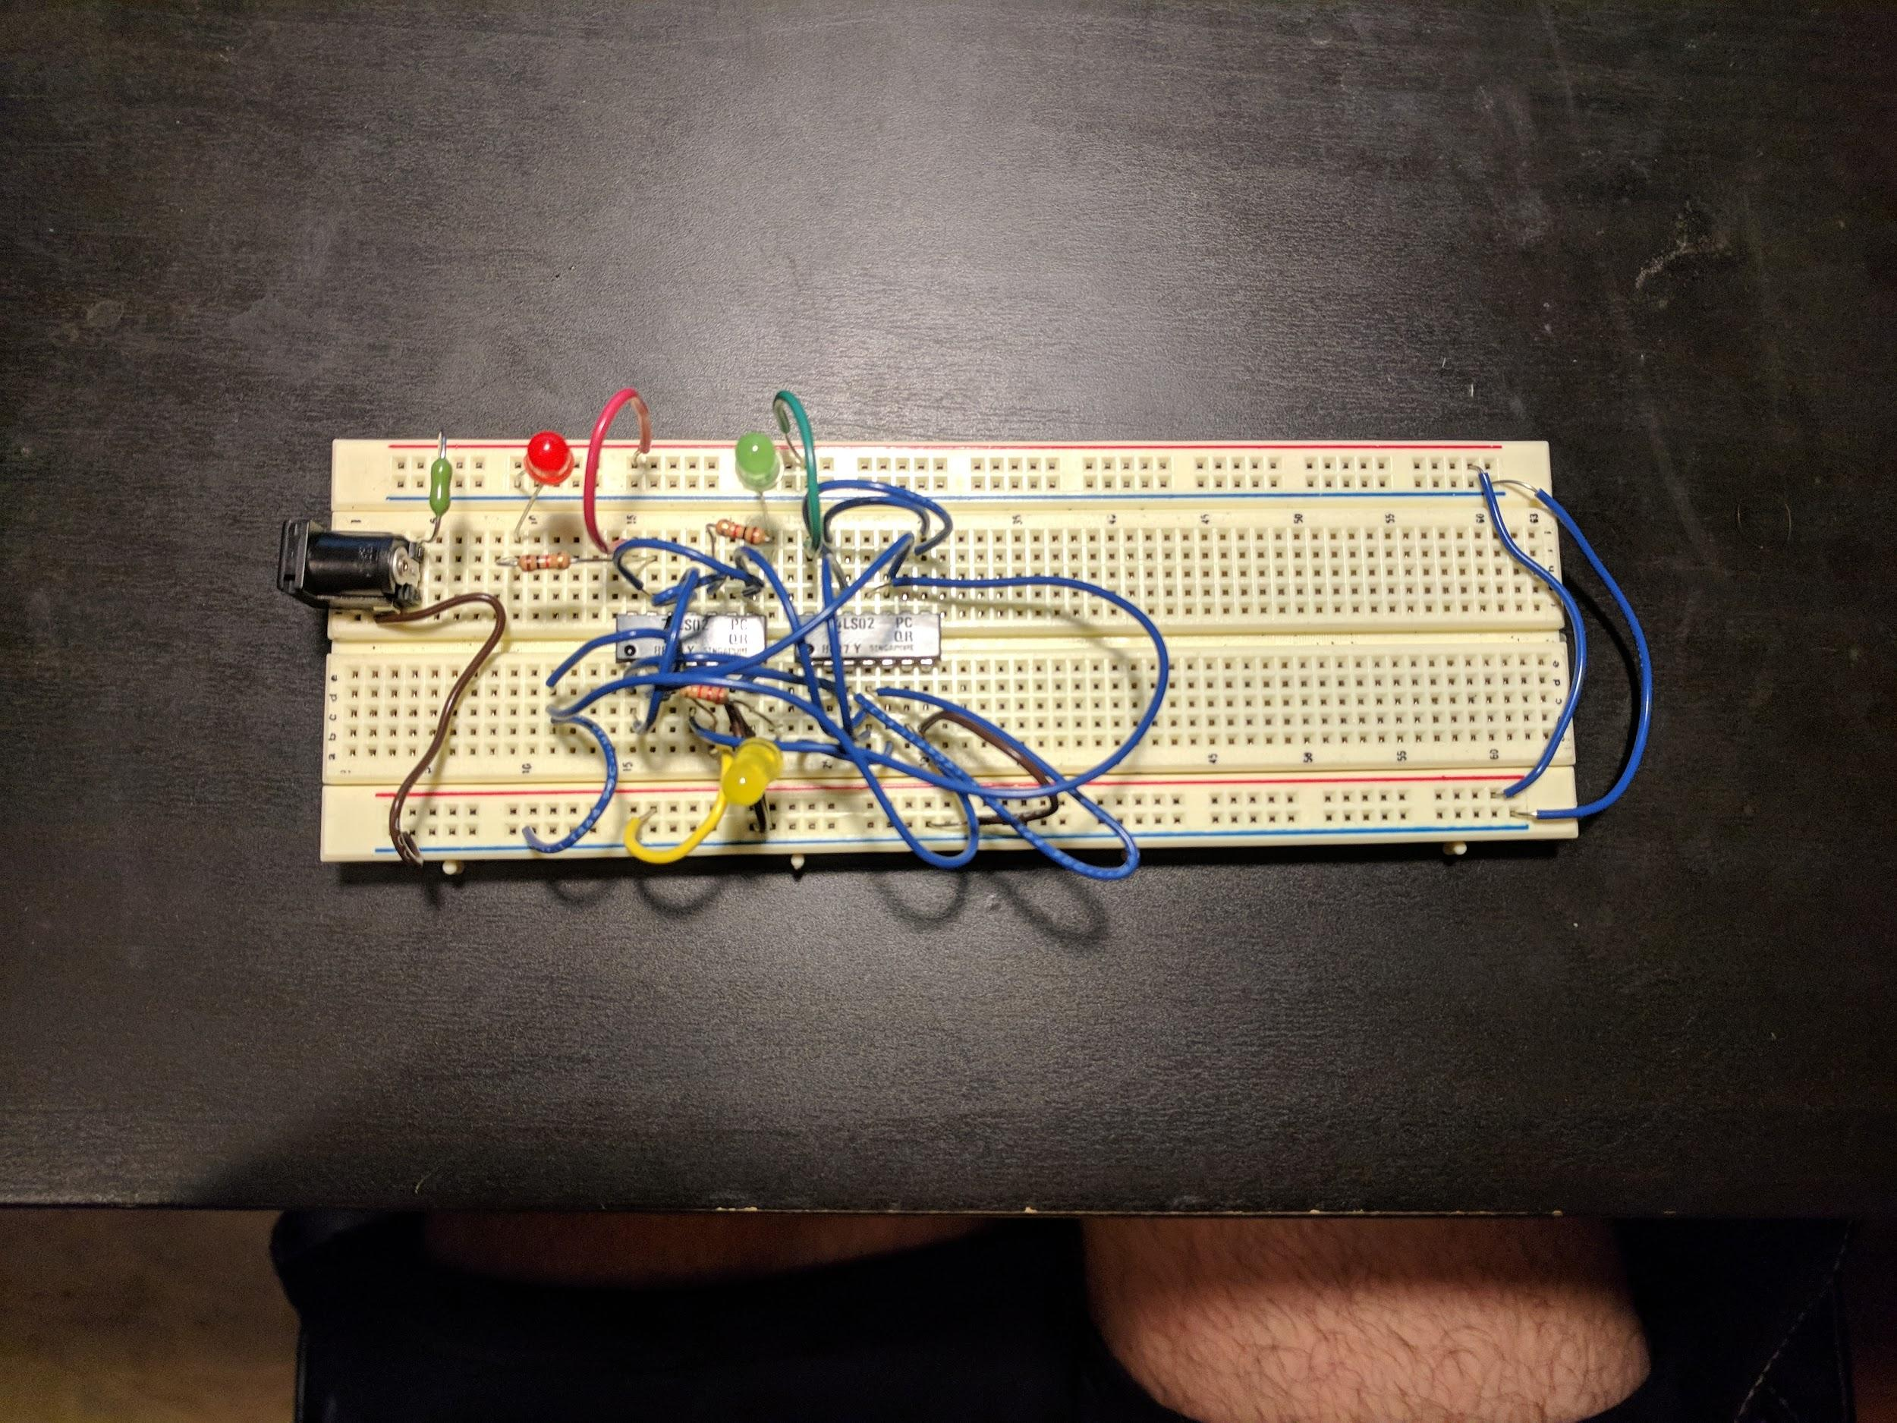

**Questions:**

Thus my propagation delay is extremely close to the expected value.

My value : 8.88 nanoseconds

Expected Value: 8 nanoseconds

**Conclusion:**

This lab was a great way to end this class. I learned how to implement circuits physically rather than just on a program. I learned how to use a breadboard as well as how important circuit diagrams can be. I also learned how to read chip schematics in order to use them properly. All in all this lab was very rewarding. I would not change my process to how to approach this lab but I would have loved to have made them much neater.

**Appendix:**

**Completed Circuits:**

**Part 1:**



**Part2:**



**Scanned Notebook Pages:**

